**50th meeting of the ERA-OSJD Contact Group**

**5Mar**2019

The 50th meeting of the ERA-OSJD Contact Group took place in Lille on 05-07 March 2019. Welcome speeches greeting the participants of the anniversary meeting were given by ERA’s Executive Director and representatives of the OSJD Committee and DG MOVE. The European Union Agency for Railways (ERA) and the Organisation for Co-operation between Railways OSJD (http://en.osjd.org/) have been in cooperation since 2007 in the framework of the Memorandum for Understanding.

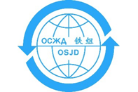

The cooperation started with a comparative analysis between technical specifications for interoperability and requirements existing in the 1520/1524 mm railway area of OSJD member countries. The outcomes of this joint work have contributed to the revision of technical specifications for interoperability. This activity is ongoing in order to cover all subsystems and to update the analysis or its parts when relevant. Furthermore, the cooperation allows for exchange of experience to coordinate measures for preservation and improvement of technical and operational compatibility on the CIS-EU border (see also “Cooperation with OSJD” [here](https://www.era.europa.eu/agency/stakeholder-relations_en#meeting3).

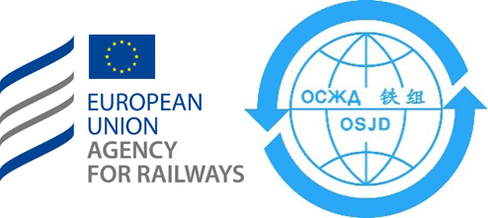

The ERA-OSJD Contact Group meets regularly (four times a year as a rule). Nine OSJD member countries contribute to the work: Georgia, Kazakhstan, Latvia, Lithuania, Moldova, Poland, Russia, Slovakia and Ukraine, along with ERA, OSJD Committee and representatives of DG MOVE, UIC and CRT Directorate.

The 50th meeting of the ERA-OSJD Contact Group took place in Lille on 5-7 March 2019. Welcome speeches greeting the participants of the anniversary meeting were given by ERA’s Executive Director and representatives of the OSJD Committee and DG MOVE.

The agenda of this meeting included the analysis of parameters for three subsystems:

* “Telematic Applications for Passenger Services (TAP)” –close to finalisation;
* “Telematic Applications for Freight (TAF)” – work underway;
* “noise” – analysis at advanced stage.

The current Memorandum of Understanding ERA-OSJD 2015-2019 expires on 31/12/2019. The two organisations are currently working on the renewal and update of the Memorandum from 1st January 2020 onwards. The renewal of the Memorandum of Understanding would allow ERA and OSJD to continue their fruitful cooperation. This cooperation aims to facilitate future development of interoperability and international transport by rail between Europe and Asia.